Task 3: [Controlling_Stepper_Motor](https://github.com/sereen-ba/Controlling_Stepper_Motor) (teamwork with Sereen)

Circuit:

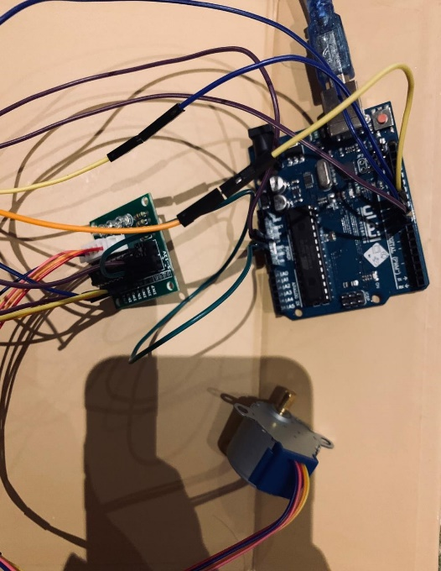

Code:

|  |
| --- |
| #include <Stepper.h> |
|  | #define STEP_PER_MOTOR_REV 32 |
|  | #define STEP_PER_OUY_REV 32*64 |
|  | Stepper stepper(STEP_PER_MOTOR_REV,8,10,9,11); |
|  | int Steps2Take; |
|  | void setup() { |
|  | // put your setup code here, to run once: |
|  |  |
|  | } |
|  |  |
|  | void loop() { |
|  | Steps2Take = STEP_PER_OUY_REV; |
|  | stepper.setSpeed(700); |
|  | stepper.step(Steps2Take); |
|  | delay(1000); |
|  |  |
|  | Steps2Take = - STEP_PER_OUY_REV; |
|  | stepper.setSpeed(500); |
|  | stepper.step(Steps2Take); |
|  | delay(1000); |
|  |  |
|  | } |